
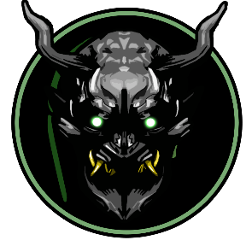

theartisticenenra@gmail.com ▪ 702: 613-6561
https://theartisticenenra.net/

Sergio Sanchez

Digital Artist
Artist Profile
Digital artist consistently and immersing himself daily in both raster-based and vector programs with an enthusiasm and love for 3D programs such as 3Ds Max, Pixologic ZBrush, and Blender.

Education
The Art Institute of Las Vegas
Bachelor of Science – Game Art and Design

Software Knowledge
Digital Illustration: Proficient in workflows for creating images through vector and raster-based means.
- Adobe Photoshop
- Adobe Illustrator
Layout: Competent in creating layouts and arranging images to best convey a message.
- Adobe Photoshop
- Adobe InDesign
Animating: Qualified to create motion and movement for assets and characters through different workflows.
- Autodesk Maya
- Adobe After Effects
Programming: Knowledgeable in C# and able to program on a basic “scripting” level.
- Visual Studio
Miscellaneous: Knowledgeable in the following programs as well.
-Adobe Premiere
-Autodesk 3DsMax and Maya
-Blender
-Pixologic Zbrush

Skills
- Concept Art - Storyboarding
- Hard Surface Modeling - Organic Modeling
- 3D Animation - 2D Animation
- Digital Painting - Layout
- Bilingual (English and Spanish) - Logo Design

Experience
June 2020 – Present
Jade Cannabis Co., Graphic Artist
- Achieved great waves of increases in social media followers by consistently marketing products, charity events, and events daily by designing graphics and scheduling them on Hootsuite.
February 2018 – February 2020
Run It Up Studios LLC, Graphic Artist
- Elevated the online presence of multiple well-known poker players and produced logos and brands for newer members of the community.

